|  |  |  |  |  |
| --- | --- | --- | --- | --- |
| |  | | --- | |  | |  | |  | |  | |
| FFH\_BOT  *This Project is focused on exploit the flex sensors in order to reproduce a five-finger hand that will be controlled with a normal glove with flex sensors attached to it, and commanded by an Arduino R3.* |
| FFH\_BOT DATE: 03 May 2017  ALBERT CASTELL VICHES (1302689) #1 DANIEL HERBÓN MÉNDEZ (1281420)#2 DAVID QUINTANA CARBELO ( 1358246 )#3 JOSEP XAVIER LÓPEZ CONEJOS (1330701)#4 |

Table of Contents

Project description 1

Electronic components 1

Scheme 2

Extra components and 3D pieces 2

Foreseen risks and contingency plan 8

FFH\_BOT

This Project is focused on exploit the flex sensors in order to reproduce a five-finger hand that will be controlled with a normal glove with flex sensors attached to it, and commanded by an Arduino R3.

# Project description

*The FFH-Bot’s project is focused on the development of a realistic robotic hand with 5 fingers, which are going to be activated by flex sensor’s analog sign. We are going to fix the flex sensors on a normal glove surface in order to control the robotic hand with one glove. Each flex sensor is going to activate one servo motor at real time, giving the impression that we are moving our own hand.   
FFH-Bot will be able to move 5 fingers, each one with 1 degree of freedom, this is because this entire project is financed by less than 100€ and we haven’t could buy enough sensors for the entire move of hand, and for us this is a university project with “Knowledge/Academics ambitions” only so we think that is better make a simpler project and finish it. By the way then hand prototype is scalable so in future we could install more servos and improve the hand realism.*

# Electronic components

This is the list of the used components:

* 5 SERVO-MOTOR (KUMAN MG 996R)
* 5 FLEX SENSORS
* ARDUINO UNO R3
* SENSOR SHIELD V5
* BREAD BOARD
* WIRE JUMPERS

# Scheme 1: Basic scheme of 5 flex sensors connected to analog pins, and 5 servos motors connected to digital pings.

# C:\Users\David\Desktop\FFH-BOT.png

# C:\Users\David\Desktop\universidad\Robotica\Untitled Sketch_bb.jpg

# Extra components and 3D pieces

|  |  |  |  |
| --- | --- | --- | --- |
| *PIECE* | *NAME AND DESCRIPTION* | *PIECE NAME* | *DESCRIPTION* |
|  | *Auriculaire: 3D pieces designed to simulate Auriculair finger* |  | *Bolt-Entertoise: 3D pieces designed to ensamble some hand joints.* |
|  | *Index: 3D pieces designed to simulate index finger* |  | *Majeure: 3D pieces designed to simulate “majeure” fnger* |
|  | *WristLargeV4:*  *Piece designed to simulate one wrist in hand* |  | *WristSmallV4:*  *Piece designed to simulate the little wrist in hand* |
|  | *ArduinoSupport:*  *Piece designed to be a support for Arduino R3* |  | *CoverFinger1: Piece designed to cover fingers* |
|  | *Ringfinger3: Piece designed to simulate the ring finger* |  | *RobCap3V2:*  *The arm’s base, and it’s the end of the arm* |
|  | *Robpart2V4:*  *One of the arm’s pieces* |  | *Robpart3V4:*  *One of the arm’s pieces* |
|  | *Robpart4V4:*  *One of the arm’s pieces* |  | *RobPart5V4:*  *One of the arm’s pieces* |
|  | *Thumb: 3D piece designed to simulate the Thumb finger* |  | *TopSurface6:*  *To cover the rovot hand* |
|  | *TopSurfaceUP6:*  *To cover the robot hand* | *C:\Users\Dani\AppData\Local\Microsoft\Windows\INetCache\Content.Word\RotaWrist1V4.png* | *RotaWirst 1:*  *First of the pieces that form the wrist* |
| *C:\Users\Dani\AppData\Local\Microsoft\Windows\INetCache\Content.Word\RotaWrist2V3.png* | *RotaWirst 2:*  *Second of the pieces that form the wrist* | *C:\Users\Dani\AppData\Local\Microsoft\Windows\INetCache\Content.Word\RotaWrist3V3.png* | *Rota Wirst 3:*  *Third of the pieces that form the wrist* |
| *C:\Users\Dani\AppData\Local\Microsoft\Windows\INetCache\Content.Word\CableHolderWristV5.png* | *Cable Holder Wrist:*  *A 3D piece designed to hold the cables in the wrist* | *C:\Users\Dani\AppData\Local\Microsoft\Windows\INetCache\Content.Word\RobServoBedV6.png* | *ServoBed:*  *Is a 3D piece where the servos are placed, and can transmit the power throw the strings* |
| *C:\Users\Dani\AppData\Local\Microsoft\Windows\INetCache\Content.Word\servo-pulleyX5.png* | *Servo Pulley:*  *With the next one pulls the strings inside the arms to move the fingers* |  | *Servo Ring:*  *With the previous one pulls the strings inside the arms to move the fingers* |
| *C:\Users\Dani\AppData\Local\Microsoft\Windows\INetCache\Content.Word\WristGearsV5.png* | *Wrist Gears:*  *Designed to move he wrist, but the hand strings are moving throw them* | *C:\Users\Dani\AppData\Local\Microsoft\Windows\INetCache\Content.Word\TensionerRightV1.png* | *Tensioner:*  *A 3D piece designed to let the strings at a minimum tension to let the fingers stay still when stopped* |

|  |  |  |  |  |
| --- | --- | --- | --- | --- |
| **Risk #** | **Description** | **Probability** (High/Medium/Low) | **Impact** (High/Medium/Low**)** | **Contingency plan** |
| 1 | Bad 3D component design | Medium | Medium | Print again the 3D component |
| 2 | Missing/corrupted component | Low | Depends on component ->  Corrupted arduino (High)  Corrupted resistor(LOW) | Order a new component |
| 3 | Bad connections that origins corruption of Arduino | Low | High | Design carefully every scheme |
| 4 | Indisposition of group member/s | Low | Medium | Increase project’s hour/day at other members. And meet the project leader if no time. |
| 5 | Low knowledge about servo/flex sensors connections/program | Medium | High | Increase project’s hour/day in investigation and use forum. |

# Foreseen risks and contingency plan

SPRINT 3

On that sprint we had problems with the servo power supply. With the USB port we only achieve 3 servos running at the same time because the amperage was too low and arduino couldn’t have enough energy and it stops the program implemented when we connect more than 3 servos.

We solve it with an external power supply. That’s are some images of our prototype of the robot hand:

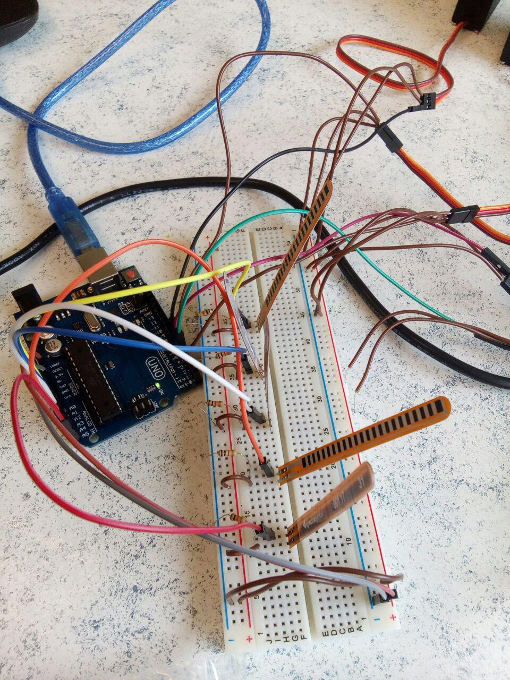

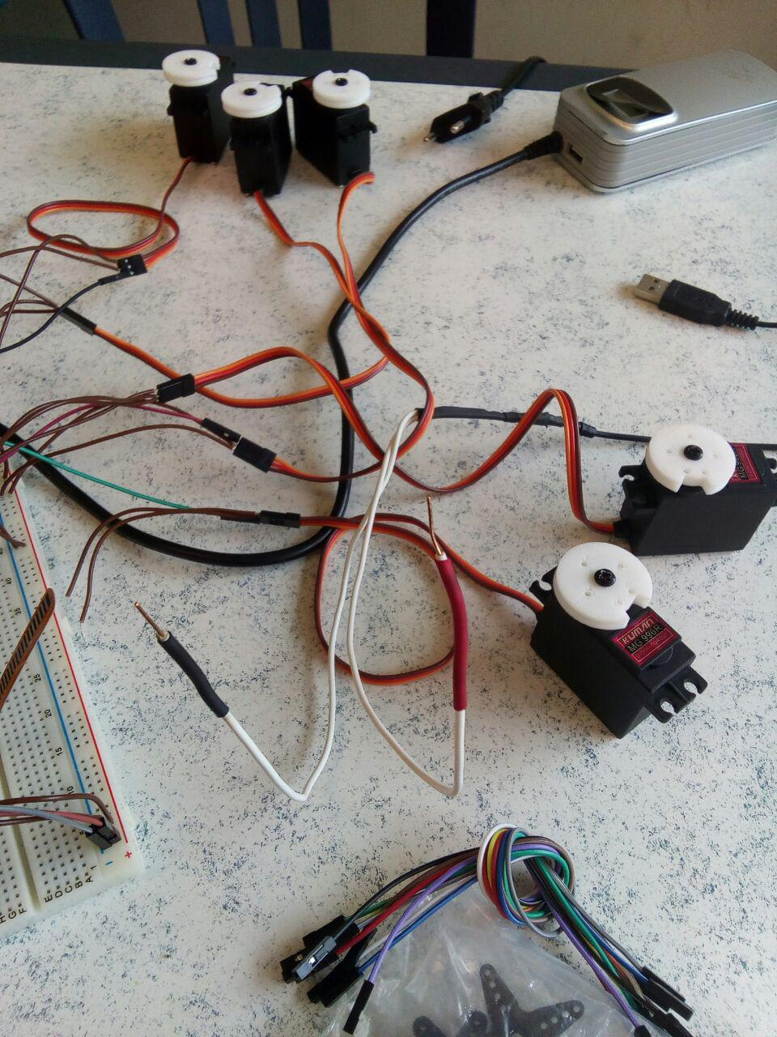

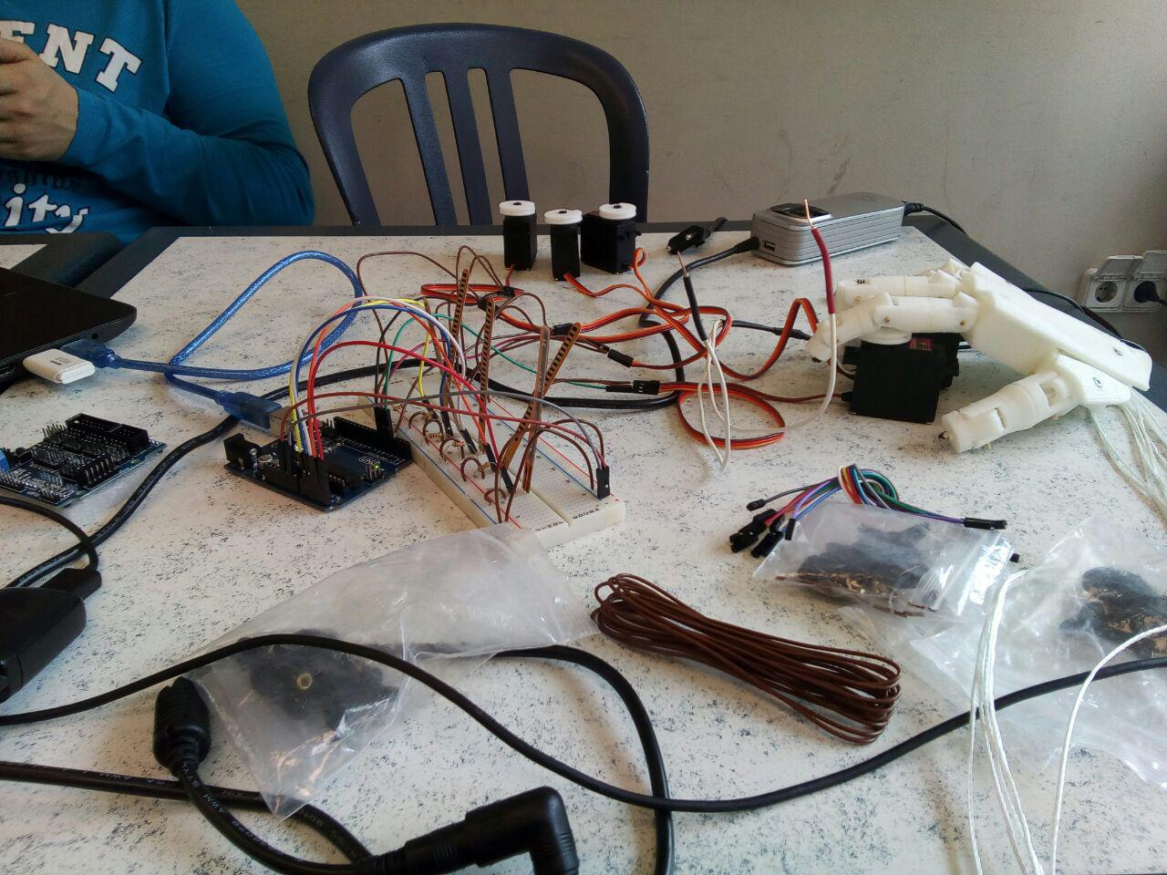

SPRINT 4

In this sprint we’ve solved the problem of the servo-motor supply, by moving them sequentially. The reason was that the IDLE amperage to maintain the servos was 200mA but the LOAD amperage was 900mA, in order to move 5 servos with 2A we only could move 2 at time, but if we move them sequentially we can move them “at time” with 50ms of delay (imperceptible to human eye).

In this deliverable we make 4 different codes:

-Mimic code: The robot hand do the same moves than the glove.

-“Paper Rock Scissor’s” loose: The robot hand always loose vs the glove playing the game “Paper Rock Scissor’s”.

-“Paper Rock Scissor’s” win: The robot hand always win vs the glove playing the game “Paper Rock Scissor’s”.

-“Paper Rock Scissor’s” random: The robot hand play paper, rock and scissors randomly when detect paper, rock and scissors of the glove.

To change the mode we will put the glove in a predetermined position during 5 seconds.

We cannot try the hand because we didn’t have the pieces to move it but when we flex the flexsensors the servomotors react correctly. Also we have a problem to change the mode but the algorithms works well.

SPRINT 5

On this deliverable we join all pieces of the robotic hand and made a functional version with mimics, we’ve got some troubles with the final glove, it was made of leather and his flexibility was questionable for the model, we have solved it with a normal glove.

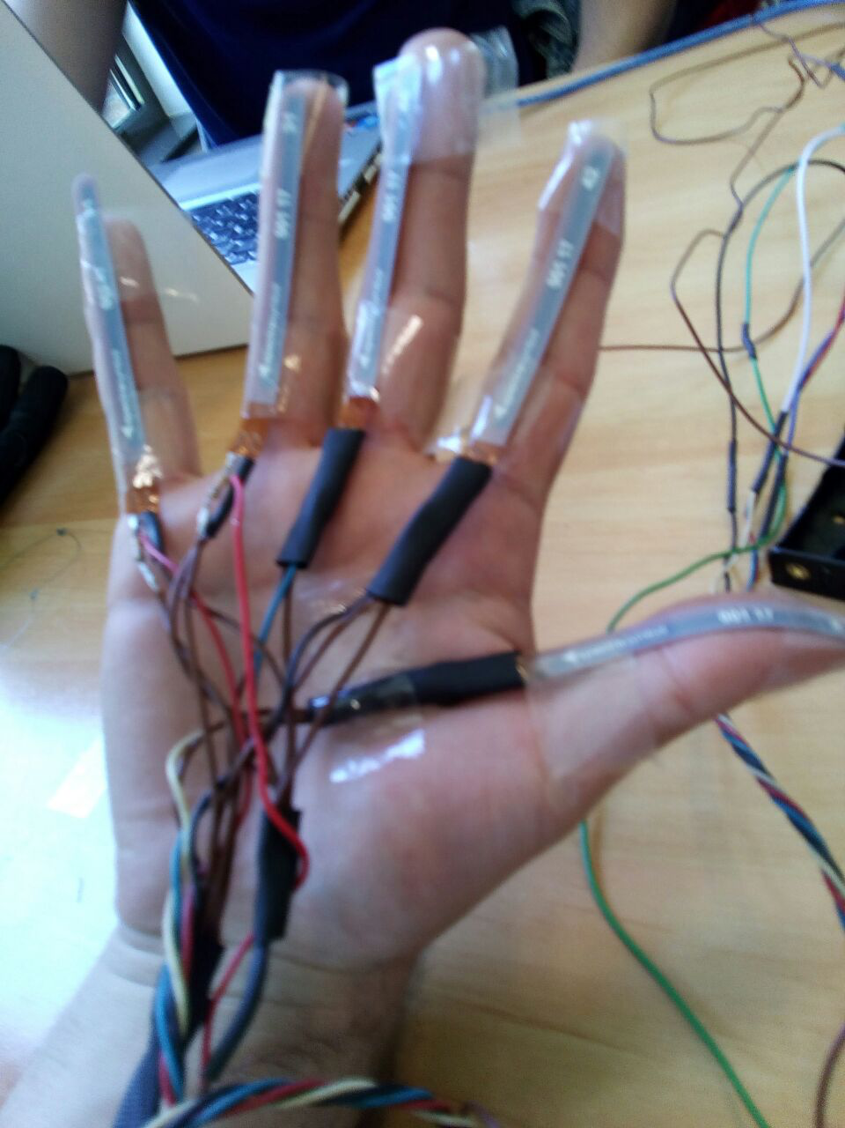 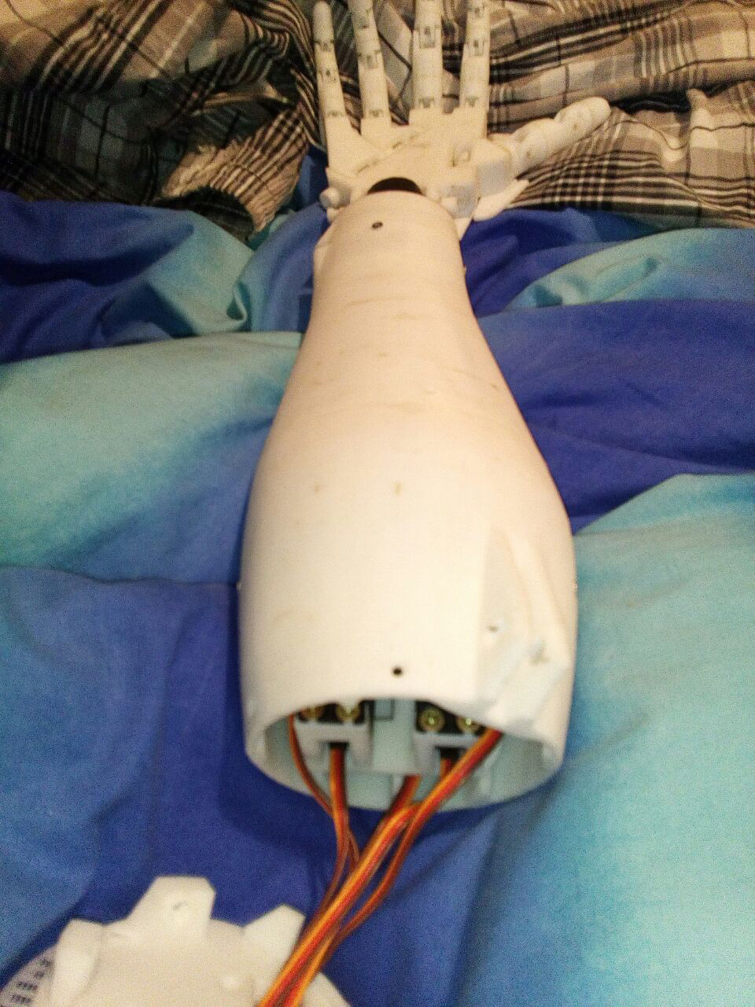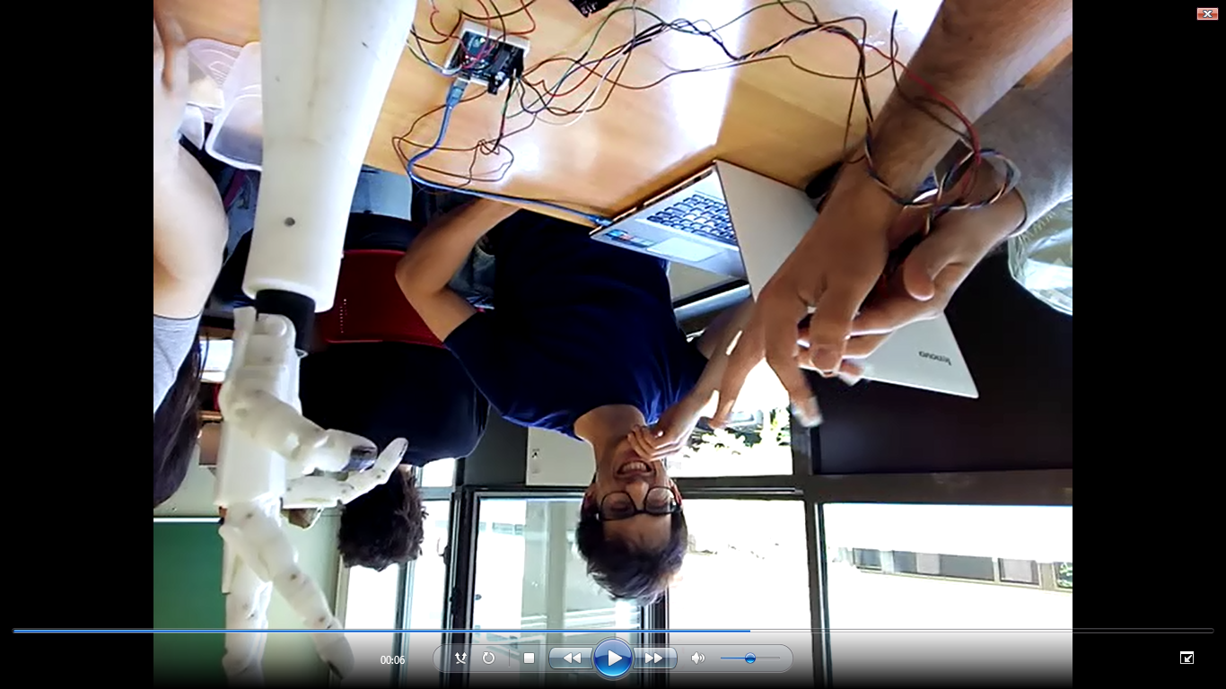

We have a problem with random mode because flex sensors are inaccurate and we have problems changing the mode.

Contingency table:

|  |  |
| --- | --- |
| **Risk** | **Resolution** |
| Bad 3D component design | We didn’t had that problem in the project. |
| Missing/corrupted component | We haven’t printed the wrist and we had improvised an alternative wrist. |
| Bad connections that origins corruption of Arduino | We didn’t had that problem in the project. |
| Indisposition of group member/s | We didn’t had that problem in the project. |
| Low knowledge about servo/flex sensors connections/program | We solve it moving the servos sequentially. |

Objective table:

|  |  |
| --- | --- |
| **Objective** | **Status** |
| Build all 3D pieces of the robotic hand | Done |
| Connect correctly all the components | Done |
| Calibrate all the servomotors and all the flex sensors | Done |
| Program a mimic algorithm for the robot hand | Done |
| Program a win “rock , paper, scissors” algorithm for the robot hand | Done |
| Program a loose “rock , paper, scissors” algorithm for the robot hand | Done |
| Program a random “rock , paper, scissors” algorithm for the robot hand | Failed |
| Change the algorithm flexing a flex sensor some seconds | Done |

Images of building process:

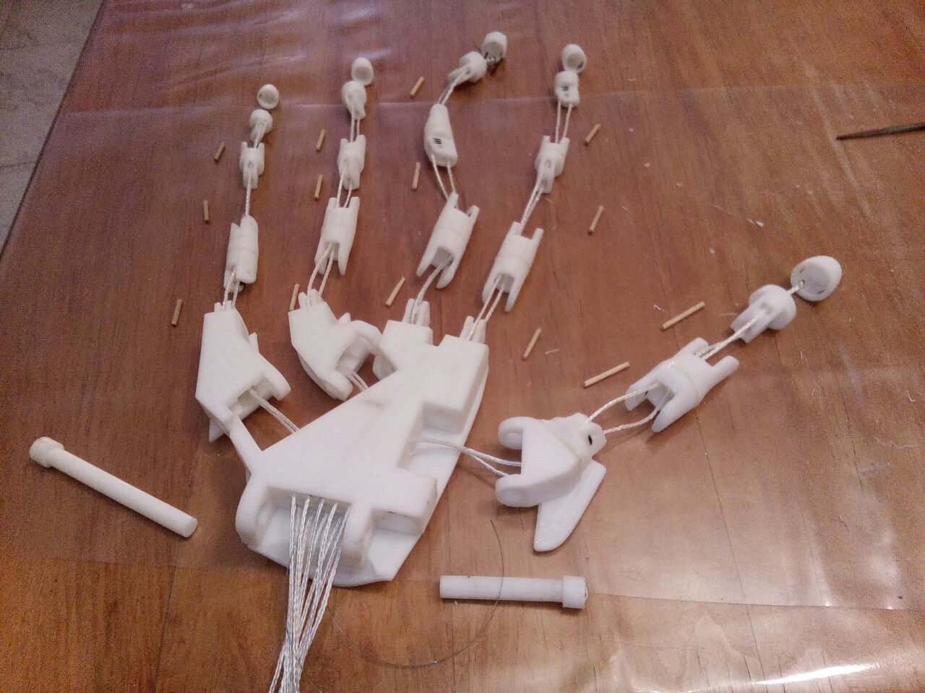

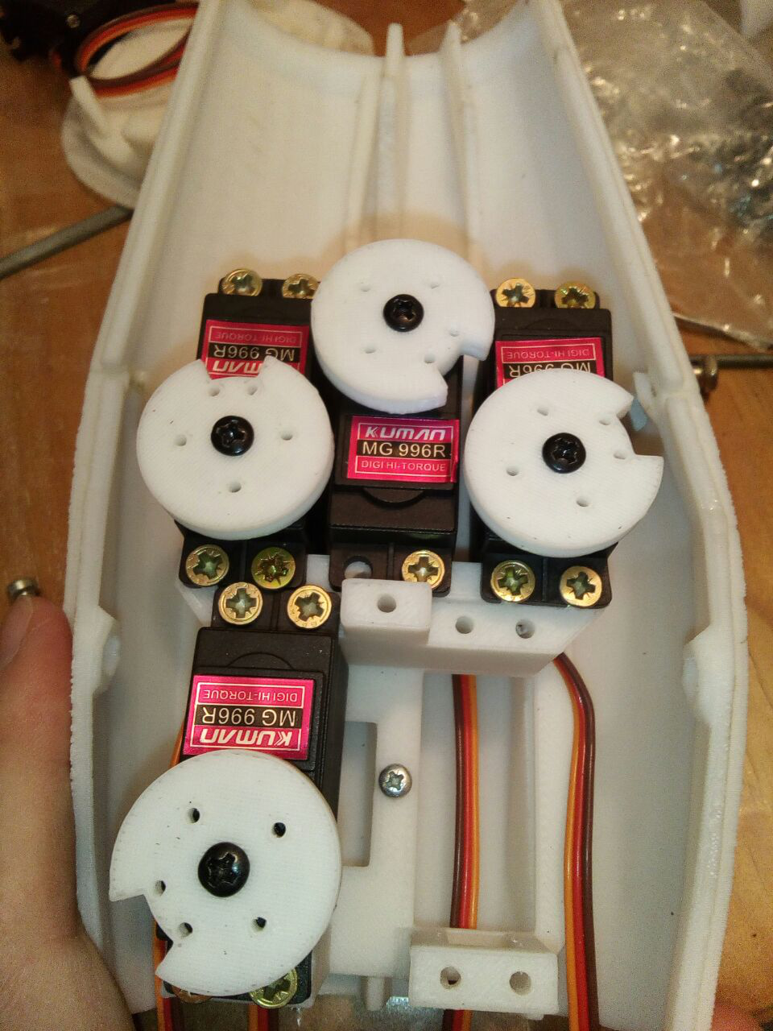

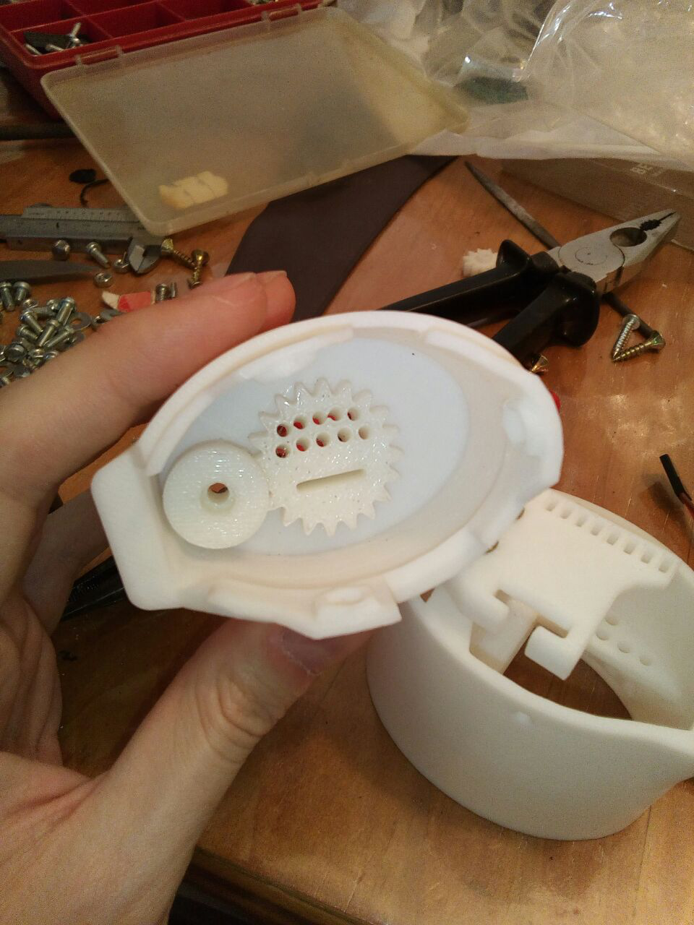

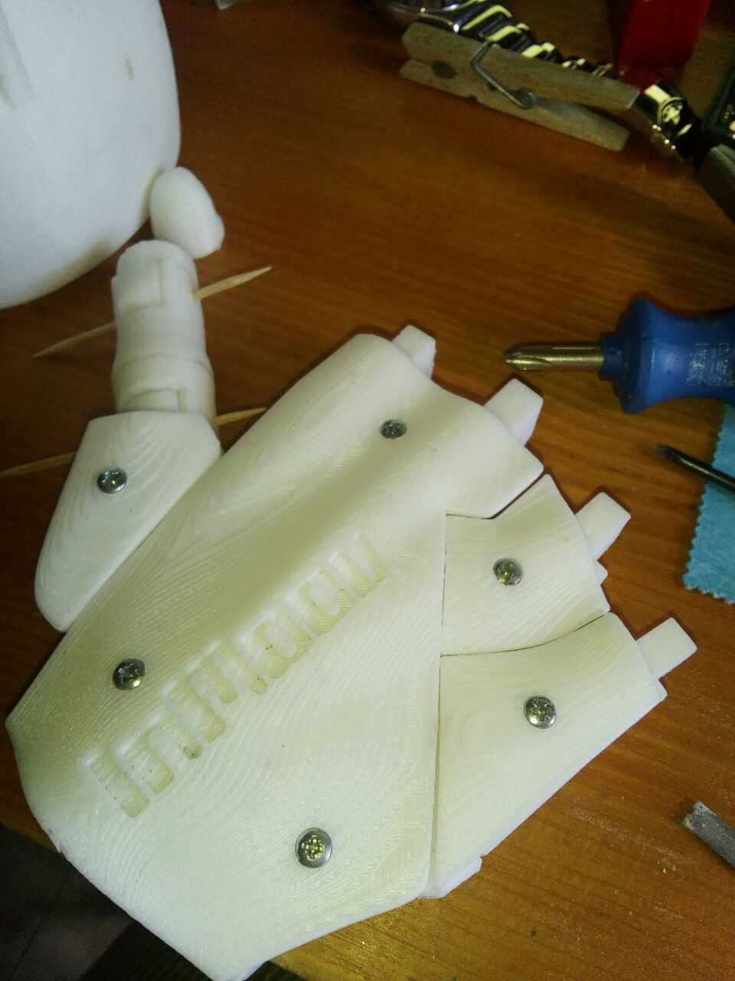

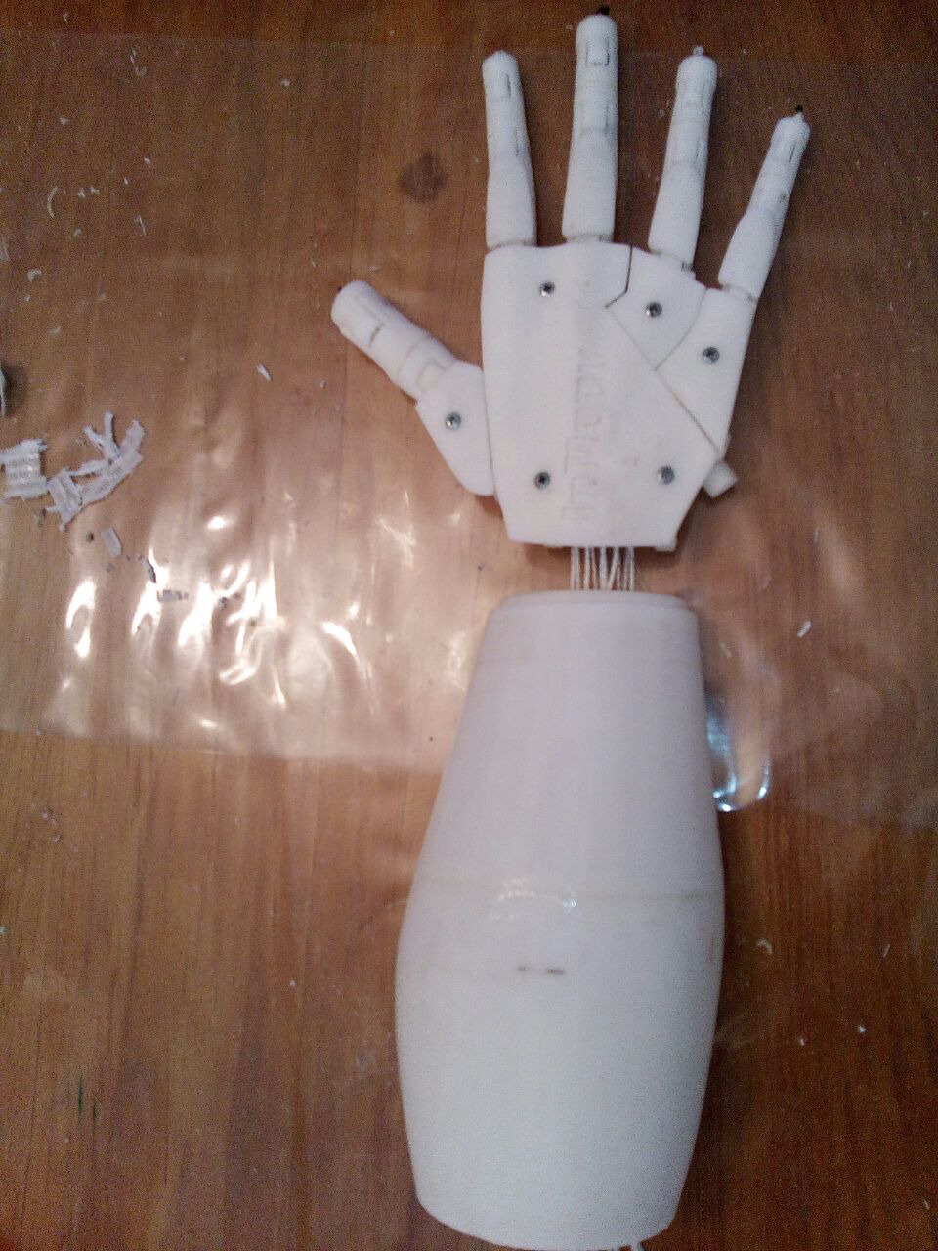

SPRINT - Extra

Adding one deliverable more I’ve been able to fix the issues with the paper, rock and scissors normal mode and add some extra moves to notice when the hand won or when we did. And I also calibrate the flex sensors resistance to make them functional again (Due to time and use the values of the resistance have changed a bit and the previous values didn’t match any more with the fingers positions).

I also improve connections and used a metal box from a computer power source to make a solid base for the arm and the Arduino connections.

The Glove still a bit dysfunctional, but it can be a good project for the new coming students to try to improve our first prototype.

Objective table:

|  |  |
| --- | --- |
| **Objective** | **Status** |
| Build all 3D pieces of the robotic hand | Done |
| Connect correctly all the components | Done |
| Calibrate all the servomotors and all the flex sensors | Done |
| Program a mimic algorithm for the robot hand | Done |
| Program a win “rock , paper, scissors” algorithm for the robot hand | Done |
| Program a loose “rock , paper, scissors” algorithm for the robot hand | Done |
| Program a random “rock , paper, scissors” algorithm for the robot hand | Done |
| Change the algorithm flexing a flex sensor some seconds | Done |

References

This project has been inspired by the following Internet projects:

<http://www.instructables.com/id/3-fingered-Arduino-Robot-Hand/>

<http://inmoov.fr/hand-and-forarm/>(3D model)

<http://inmoov.fr/inmoov-stl-parts-viewer/?bodyparts=Right-Hand> (3D Pieces)